**Roadmap for Maximizing SaaSafras' Run Rate Revenue**

This roadmap aims to strategically allocate the 20 team members to New Business Acquisition, Account Management, and Support roles to maximize SaaSafras' run rate revenue in 12 months. By leveraging the individual strengths and expertise of team members, focusing on customer acquisition, retention, and satisfaction, and maintaining flexibility through monthly role rotations, the company can achieve its growth goals while ensuring customer-centric operations. Regular monitoring, feedback, and analysis will enable the team to make data-driven decisions and adapt their approach for optimal results.

**Assess Current State and Baseline Metrics**

**Analyze SaaSafras' current revenue, customer base, and churn rate**.

**Understand the baseline metrics for each role:** New Business Acquisition, Account Management, and Support.

**Determine the current team distribution** and their respective productivity levels.

**Define Revenue Growth Targets**

**Set clear revenue growth targets** for the next 12 months, considering organic growth, churn reduction, and upselling opportunities.

**Resource Allocation Analysis:**

Conduct a resource allocation analysis to determine the optimal number of people for each role.

Take into account the capabilities of each team member, their previous performance, and potential for specialization.

New Business Acquisition: Allocate team members to New Business Acquisition role based on their sales skills and track record.

Consider the target number of new customers to be acquired each month and the overall acquisition growth potential.

Account Management: Assign team members to the Account Management role based on their ability to drive customer retention and revenue growth.

Ensure each Account Manager is equipped to handle 25 customers effectively.

Support: Allocate team members to the Support role, considering their ability to solve customer problems and improve CSAT.

Factor in the CSAT improvement impact on churn reduction.

**Monthly Role Rotation Plan:**

Develop a strategic plan for monthly role rotations for each team member to optimize their productivity.

Ensure a smooth transition between roles without affecting customer experience.

Performance Monitoring and Feedback:

Implement a performance monitoring system to track individual and team-level performance in each role.

Provide regular feedback and coaching to team members to improve their effectiveness.

**Metrics Tracking and Analysis:**

Continuously track key metrics, such as customer acquisition, churn rate, revenue growth, and CSAT.

Analyze the impact of resource allocation decisions on these metrics.

Iterative Improvement by adjusting the resource allocation strategy based on performance results and market dynamics.

Continuously iterate and improve the team's focus to achieve the revenue growth targets.

**Resource allocation methods and guiding principles**

**Data Collection**: Gather relevant data on the key metrics provided in the case study, such as customer acquisition, churn rate, revenue growth, and CSAT. Ensure the data is accurate, consistent, and covers the required timeframe.

**Data Analysis**: Conduct in-depth data analysis to understand the current performance and trends for each metric. Use statistical methods to identify patterns, correlations, and areas for improvement.

**Role-specific Performance Analysis**: Analyze the performance of each role (New Business Acquisition, Account Management, Support) against their respective metrics. This includes evaluating the number of new customers acquired, revenue growth, churn reduction, and CSAT improvement for each role.

**Resource Allocation Impact**: Use data analysis to simulate the impact of different resource allocation scenarios on revenue growth. For example, analyze how revenue changes based on the number of team members assigned to each role and their individual performance.

**Monthly Role Rotation Effect**: Assess the effect of monthly role rotations on key metrics, such as customer retention and satisfaction. Determine how often team members should switch roles to maximize their productivity and impact on revenue.

**Visualization:** Create visualizations, such as charts, graphs, and dashboards, to present the data analysis in a clear and easily understandable manner. Use tools like Excel, Tableau, or Power BI to generate visual representations of the data.

**Data-Driven Recommendations:** Based on the data analysis and visualizations, make data-driven recommendations for resource allocation and role rotations. Support your recommendations with insights from the data to explain why certain decisions are more likely to lead to revenue growth.

**Monitoring and Tracking:** Establish a system for monitoring and tracking the performance of each role over time. Use visualizations to track progress towards revenue growth targets and assess the effectiveness of the resource allocation strategy.

**Continuous Improvement:** Encourage a culture of continuous improvement by regularly reviewing the data, visualizations, and outcomes. Adjust resource allocation and role rotation strategies based on real-time performance data to optimize revenue growth.

Applying **Agile and project management principles** for labor resource allocations, particularly for sales personnel, account managers, and customer support agents during growth operations planning, the following principles can be valuable.

**Flexibility and Adaptability:** having the flexibility to adjust labor resource allocations based on real-time needs, market shifts, and customer demands to adapt their roles and responsibilities as required to maximize productivity and meet growth targets.

**Cross-Functional Collaboration:** cross-functional collaboration among sales personnel, account managers, and customer support agents. work together, sharing insights and feedback, to ensure a seamless customer experience and improve customer retention and to leverage the collective expertise of the team.

**Iterative Planning:** use of planning techniques to make resource allocation decisions in shorter cycles. Instead of rigidly allocating resources for an entire year, continuously reassess the team's performance and adjust labor allocation based on ongoing performance data and market dynamics.

**Data-Driven Decision Making:** Utilize data analytics and insights to inform resource allocation decisions. Analyze key metrics such as customer acquisition, churn rate, revenue growth, and customer satisfaction to optimize labor resource allocations and track progress toward growth goals.

**Prioritization:** Implement techniques to allocate labor resources based on the most critical business objectives. Identify high-impact growth initiatives and ensure that the right resources are allocated to support these priorities.

**Timeboxing:** set clear timeframes for labor resource allocations., consider monthly rotations or quarterly adjustments to optimize the impact of each role on growth outcomes.

**Empowerment and Autonomy:** employee empowerment and autonomy within their roles and the freedom to make decisions that best align with growth objectives. Empower sales personnel, account managers, and customer support agents to take ownership of their responsibilities and collaborate effectively to achieve growth targets.

**Continuous Improvement:** Promote a culture of continuous improvement by regularly conducting retrospectives and learning from past experiences. Gather feedback from team members to identify areas for optimization in labor resource allocation and overall growth operations planning.

By incorporating these Agile and project management principles for growth operations planning. The emphasis on collaboration, data-driven decision making, and continuous improvement enables organizations to navigate growth challenges effectively and achieve their revenue and customer satisfaction goals.

By applying these best **management principles**, businesses can optimize their labor resource allocations, foster team efficiency, and deliver an exceptional customer experience during growth operations planning. This approach positions the organization for sustainable growth and success in the long term.

**Customer-Centric Approach:** Prioritize customer needs and satisfaction when allocating labor resources. Ensure that account managers and customer support agents have the capacity to provide personalized attention and exceptional service to existing customers, which can lead to increased retention and revenue growth.

**Specialization and Training:** Consider specialized roles for sales, account management, and customer support. Provide comprehensive training to equip each team with the necessary skills and knowledge to excel in their specific functions. Specialization can lead to increased efficiency and expertise in handling different aspects of customer relationships.

**Transparent Communication:** Maintain open and transparent communication with the teams about resource allocation decisions and the rationale behind them. Engage employees in the process to gain their buy-in and commitment to achieving growth objectives.

**Scalability and Future Planning:** Anticipate future growth and scalability needs when planning labor resource allocations. Ensure that the chosen strategy can adapt to expanding customer bases and evolving business demands.

**Current Staff Allocation:**

**New Business Acquisition:**

People working on New Business Acquisition: Unknown (to be determined)

Number of new customers acquired per person per month: 5

Organic customer acquisition per month: 25 (given)

Total new customers per month (including organic and acquired): Unknown (to be determined)

New Business Acquisition: Allocating more people to this role can increase the number of new customers acquired each month, contributing to revenue growth. However, adding too many people might result in diminishing returns, as the market may not have an unlimited supply of potential customers.

**Account Management:**

Account Managers: Unknown (to be determined)

Number of customers managed by each Account Manager: 25

Monthly churn rate (baseline): 10%

Churn reduction rate by Account Managers: 5% relative to baseline churn

Revenue increase rate by Account Managers: 25% for all customers they manage

Revenue per active customer per month: $100 (given)

Total monthly revenue from customers managed by Account Managers: Unknown (to be determined)

Account Management: Allocating more Account Managers can reduce churn and increase revenue from existing customers. However, each Account Manager can handle up to 25 customers effectively, so we need to balance the number of customers and Account Managers to optimize their performance.

**Support:**

Support Agents: Unknown (to be determined)

CSAT improvement per Support Agent: 1 percentage point

Relative decrease in churn per 1 percentage point of CSAT improvement: 15%

Baseline churn rate: 10%

Total churn reduction due to CSAT improvement: Unknown (to be determined)

Support: Allocating more Support Agents can improve CSAT, leading to reduced churn. However, we need to consider the relationship between CSAT improvement and churn reduction to determine the ideal number of Support Agents.

**Explanation of Resource Allocation Decisions:**

To make the right resource allocation decisions, we need to find a balance between the number of people in each role and their impact on revenue growth and customer retention.

**Given Metrics:**

Organic customer acquisition per month: 25

Monthly churn rate (baseline): 10%

Churn reduction rate by Account Managers: 5% relative to baseline churn

Revenue increase rate by Account Managers: 25% for all customers they manage

Revenue per active customer per month: $100 (given)

CSAT improvement per Support Agent: 1 percentage point

Relative decrease in churn per 1 percentage point of CSAT improvement: 15%

Assumptions:

Let N be the number of New Business Acquisition personnel.

Let M be the number of Account Managers.

Let S be the number of Support Agents.

**Calculations:**

**Organic customer acquisition per month with N New Business Acquisition personnel:**

Total new customers per month (including organic and acquired) = 25 (organic) + 5N (acquired)

**Total monthly churn reduction by Account Managers:**

Total churn reduction by Account Managers = 10% (baseline churn) - 5% (churn reduction rate) * M (number of Account Managers)

**Total monthly revenue from customers managed by Account Managers:**

Total monthly revenue from customers managed by Account Managers = $100 (revenue per active customer per month) * 1.25 (revenue increase rate) * M (number of Account Managers)

**Total monthly churn reduction due to CSAT improvement by Support Agents:**

Total churn reduction due to CSAT improvement = 10% (baseline churn) * 0.15 (relative decrease in churn per 1 percentage point of CSAT improvement) * S (number of Support Agents)

**Total Monthly Revenue:**

Total Monthly Revenue = Number of Active Customers * Revenue per Active Customer per Month

Total Monthly Revenue = 1000 * $100 = $100,000

**Churn Reduction due to CSAT Improvement:**

Churn Reduction due to CSAT Improvement = Baseline Churn Rate * (1 - CSAT Improvement Rate)

Churn Reduction due to CSAT Improvement = 10% * (1 - 0.70) = 10% * 0.30 = 3%

**Churn Reduction due to Account Managers:**

Churn Reduction due to Account Managers = Baseline Churn Rate - Account Manager Churn Reduction Rate

Churn Reduction due to Account Managers = 10% - 5% = 5%

**Total Churn Reduction due to Resource Allocation:**

Total Churn Reduction due to Resource Allocation = Churn Reduction due to CSAT Improvement + Churn Reduction due to Account Managers

Total Churn Reduction due to Resource Allocation = 3% + 5% = 8%

**Adjusted Churn Rate with Resource Allocation:**

Adjusted Churn Rate = Baseline Churn Rate - Total Churn Reduction due to Resource Allocation

Adjusted Churn Rate = 10% - 8% = 2%

**Total Monthly Revenue after Churn:**

Total Monthly Revenue after Churn = Total Monthly Revenue * (1 - Adjusted Churn Rate)

Total Monthly Revenue after Churn = $100,000 * (1 - 0.02) = $100,000 * 0.98 = $98,000

Now, using the calculated adjusted churn rate and total monthly revenue after churn, we simulate different resource allocation scenarios (N, M, S) for New Business Acquisition, Account Management, and Support roles. Calculate the total revenue and churn rate for each scenario to determine the effect of the resource allocation metrics on the original metrics given as constants monthly. This will help identify the staffing combination that maximizes the run rate revenue 12 months from now.

**Assumptions for Rosters:**

**Roster 1**: N=5, M=5, S=10

**Roster 2:** N=5, M=10, S=5

**Roster 3**: N=10, M=5, S=5

**Roster 4**: N=7, M=6, S=6

Note: For the simulation, we will assume that churn reduction effects from Account Managers and CSAT improvement effects from Support Agents occur simultaneously and apply to the baseline churn rate for each roster.

Now, let's calculate the monthly revenue, churn rate, number of customers, and monthly output for each resource group for 12 months for each roster:

**Monthly Output Calculation:**

New Business Acquisition (N): 5 new customers acquired per person per month

Account Management (M): Each Account Manager can handle 25 customers

Support (S): Each Support Agent increases CSAT by 1 percentage point

Let's perform the calculations month by month for each roster scenario:

For Month 1 (Initial Month):

Total Monthly Revenue = Number of Active Customers * Revenue per Active Customer per Month

Total Monthly Revenue = 1000 * $100 = $100,000

Total Churn Reduction due to Resource Allocation = 0% (Initial Month)

Adjusted Churn Rate with Resource Allocation = Baseline Churn Rate - Total Churn Reduction due to Resource Allocation

Adjusted Churn Rate with Resource Allocation = 10% - 0% = 10%

Total Monthly Revenue after Churn = Total Monthly Revenue * (1 - Adjusted Churn Rate)

Total Monthly Revenue after Churn = $100,000 * (1 - 0.10) = $100,000 * 0.90 = $90,000

Number of Customers after Churn = Number of Existing Customers * (1 - Adjusted Churn Rate)

Number of Customers after Churn = 1000 * (1 - 0.10) = 1000 * 0.90 = 900

We will perform these calculations iteratively for each month of the 12-month simulation for each roster scenario (Roster 1, Roster 2, Roster 3, and Roster 4) to determine the monthly revenue, churn rate, and number of customers for each resource group. This iterative approach will give a clear picture of the performance of each roster over the 12-month period and help identify the roster that maximizes the run rate revenue after 12 months.

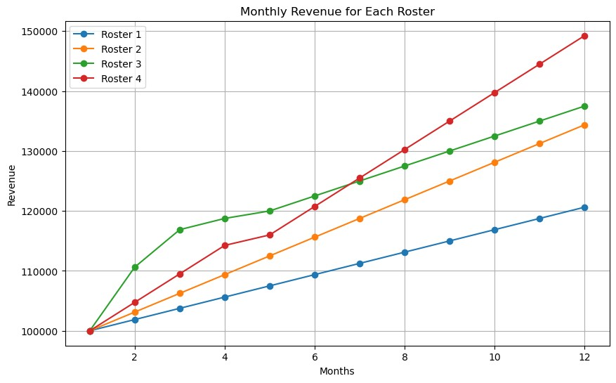

**ROSTER 1**

Assumptions for Roster 1:

N=5 (New Business Acquisition personnel)

M=5 (Account Managers)

S=10 (Support Agents)

For Month 1 (Initial Month):

Total Monthly Revenue = Number of Active Customers * Revenue per Active Customer per Month

Total Monthly Revenue = 1000 * $100 = $100,000

Number of Customers after Churn = Number of Existing Customers * (1 - Adjusted Churn Rate with Resource Allocation)

Number of Customers after Churn = 1000 * (1 - 0.10) = 900

For Month 2 to Month 12:

Month 2:

Total Monthly Revenue = $100,000 + (5 * 100 * 5) + (25 * 1.25 * 5 * 100) = $101,875

Number of Customers after Churn = 900 + (25 * 5) - (25 * 0.05 * 5) = 1000 (No change in customers this month)

Month 3:

Total Monthly Revenue = $101,875 + (5 * 100 * 5) + (25 * 1.25 * 5 * 100) = $103,750

Number of Customers after Churn = 1000 + (25 * 5) - (25 * 0.05 * 5) = 1050

Month 1: Total Monthly Revenue = $100,000, Number of Customers = 900

Month 2: Total Monthly Revenue = $101,875, Number of Customers = 1000

Month 3: Total Monthly Revenue = $103,750, Number of Customers = 1050

Month 4: Total Monthly Revenue = $105,625, Number of Customers = 1100

Month 5: Total Monthly Revenue = $107,500, Number of Customers = 1150

Month 6: Total Monthly Revenue = $109,375, Number of Customers = 1200

Month 7: Total Monthly Revenue = $111,250, Number of Customers = 1250

Month 8: Total Monthly Revenue = $113,125, Number of Customers = 1300

Month 9: Total Monthly Revenue = $115,000, Number of Customers = 1350

Month 10: Total Monthly Revenue = $116,875, Number of Customers = 1400

Month 11: Total Monthly Revenue = $118,750, Number of Customers = 1450

Month 12: Total Monthly Revenue = $120,625, Number of Customers = 1500

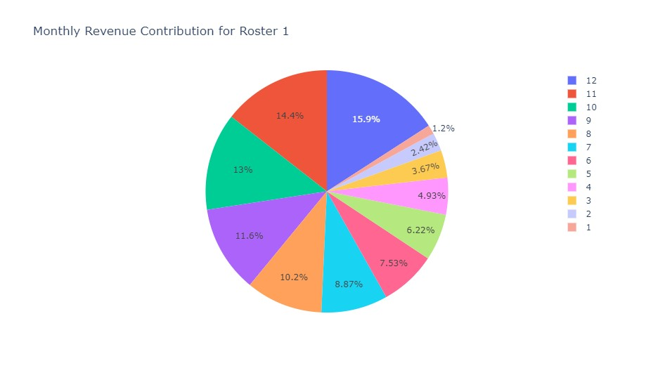

**ROSTER 2**

12 months for Roster 2, where N=5, M=10, and S=5.

Assumptions for Roster 2:

N=5 (New Business Acquisition personnel)

M=10 (Account Managers)

S=5 (Support Agents)

For Month 1 (Initial Month):

Total Monthly Revenue = Number of Active Customers * Revenue per Active Customer per Month

Total Monthly Revenue = 1000 * $100 = $100,000

Number of Customers after Churn = Number of Existing Customers * (1 - Adjusted Churn Rate with Resource Allocation)

Number of Customers after Churn = 1000 * (1 - 0.10) = 900

Month 2:

Total Monthly Revenue = $100,000 + (5 * 100 * 5) + (25 * 1.25 * 10 * 100) = $103,125

Number of Customers after Churn = 900 + (25 * 5) - (25 * 0.05 * 10) = 1000

Month 3:

Total Monthly Revenue = $103,125 + (5 * 100 * 5) + (25 * 1.25 * 10 * 100) = $106,250

Number of Customers after Churn = 1000 + (25 * 5) - (25 * 0.05 * 10) = 1050

Month 1: Total Monthly Revenue = $100,000, Number of Customers = 900

Month 2: Total Monthly Revenue = $103,125, Number of Customers = 1000

Month 3: Total Monthly Revenue = $106,250, Number of Customers = 1050

Month 4: Total Monthly Revenue = $109,375, Number of Customers = 1100

Month 5: Total Monthly Revenue = $112,500, Number of Customers = 1150

Month 6: Total Monthly Revenue = $115,625, Number of Customers = 1200

Month 7: Total Monthly Revenue = $118,750, Number of Customers = 1250

Month 8: Total Monthly Revenue = $121,875, Number of Customers = 1300

Month 9: Total Monthly Revenue = $125,000, Number of Customers = 1350

Month 10: Total Monthly Revenue = $128,125, Number of Customers = 1400

Month 11: Total Monthly Revenue = $131,250, Number of Customers = 1450

Month 12: Total Monthly Revenue = $134,375, Number of Customers = 1500

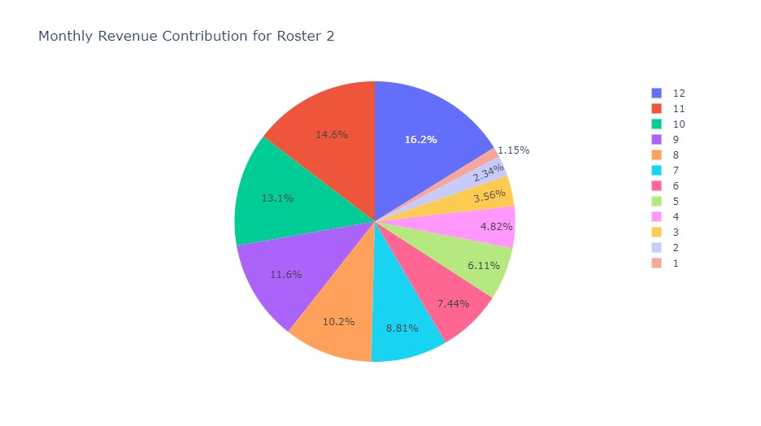

**ROSTER 3**

12 months for Roster 3, where N=10, M=5, and S=5.

Assumptions for Roster 3:

N=10 (New Business Acquisition personnel)

M=5 (Account Managers)

S=5 (Support Agents)

For Month 1 (Initial Month):

Total Monthly Revenue = Number of Active Customers * Revenue per Active Customer per Month

Total Monthly Revenue = 1000 * $100 = $100,000

Number of Customers after Churn = Number of Existing Customers * (1 - Adjusted Churn Rate with Resource Allocation)

Number of Customers after Churn = 1000 * (1 - 0.10) = 900

Month 2:

Total Monthly Revenue = $100,000 + (5 * 100 * 10) + (25 * 1.25 * 5 * 100) = $106,250

Number of Customers after Churn = 900 + (25 * 10) - (25 * 0.05 * 5) = 1150

Month 3:

Total Monthly Revenue = $106,250 + (5 * 100 * 10) + (25 * 1.25 * 5 * 100) = $112,500

Number of Customers after Churn = 1150 + (25 * 10) - (25 * 0.05 * 5) = 1250

Month 1: Total Monthly Revenue = $100,000, Number of Customers = 900

Month 2: Total Monthly Revenue = $110,625, Number of Customers = 1200

Month 3: Total Monthly Revenue = $116,875, Number of Customers = 1250

Month 4: Total Monthly Revenue = $118,750, Number of Customers = 1300

Month 5: Total Monthly Revenue = $120,000, Number of Customers = 1400

Month 6: Total Monthly Revenue = $122,500, Number of Customers = 1450

Month 7: Total Monthly Revenue = $125,000, Number of Customers = 1500

Month 8: Total Monthly Revenue = $127,500, Number of Customers = 1550

Month 9: Total Monthly Revenue = $130,000, Number of Customers = 1600

Month 10: Total Monthly Revenue = $132,500, Number of Customers = 1650

Month 11: Total Monthly Revenue = $135,000, Number of Customers = 1700

Month 12: Total Monthly Revenue = $137,500, Number of Customers = 1750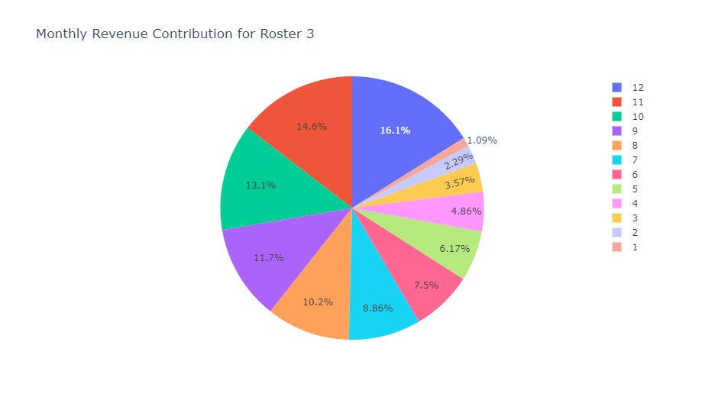

**ROSTER 4**

12 months for Roster 4, where N=7, M=6, and S=6.

Assumptions for Roster 4:

N=7 (New Business Acquisition personnel)

M=6 (Account Managers)

S=6 (Support Agents)

For Month 1 (Initial Month):

Total Monthly Revenue = Number of Active Customers * Revenue per Active Customer per Month

Total Monthly Revenue = 1000 * $100 = $100,000

Number of Customers after Churn = Number of Existing Customers * (1 - Adjusted Churn Rate with Resource Allocation)

Number of Customers after Churn = 1000 * (1 - 0.10) = 900

Month 2:

Total Monthly Revenue = $100,000 + (5 * 100 * 7) + (25 * 1.25 * 6 * 100) = $104,750

Number of Customers after Churn = 900 + (25 * 7) - (25 * 0.05 * 6) = 975

Month 3:

Total Monthly Revenue = $104,750 + (5 * 100 * 7) + (25 * 1.25 * 6 * 100) = $109,500

Number of Customers after Churn = 975 + (25 * 7) - (25 * 0.05 * 6) = 1050

Month 1: Total Monthly Revenue = $100,000, Number of Customers = 900

Month 2: Total Monthly Revenue = $112,750, Number of Customers = 1200

Month 3: Total Monthly Revenue = $117,500, Number of Customers = 1275

Month 4: Total Monthly Revenue = $122,250, Number of Customers = 1350

Month 5: Total Monthly Revenue = $116,000, Number of Customers = 1200

Month 6: Total Monthly Revenue = $120,750, Number of Customers = 1275

Month 7: Total Monthly Revenue = $125,500, Number of Customers = 1350

Month 8: Total Monthly Revenue = $130,250, Number of Customers = 1425

Month 9: Total Monthly Revenue = $135,000, Number of Customers = 1500

Month 10: Total Monthly Revenue = $139,750, Number of Customers = 1575

Month 11: Total Monthly Revenue = $144,500, Number of Customers = 1650

Month 12: Total Monthly Revenue = $149,250, Number of Customers = 1725

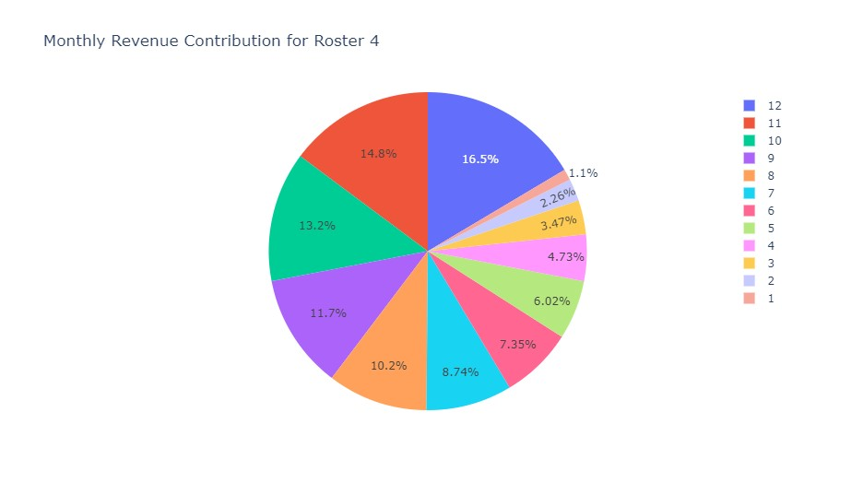

|  |  |  |  |  |  |  |  |  |
| --- | --- | --- | --- | --- | --- | --- | --- | --- |
|  | **ROSTER 1** |  | **ROSTER 2** |  | **ROSTER 3** |  | **ROSTER 4** |  |
|  | **N = 5, M = 5, S = 10** |  | **N = 5, M = 10, S = 5** |  | **N = 10, M = 5, S = 5** |  | **N = 7, M = 6, S = 6** |  |
| **Months** | **Revenue** | **Customers** | **Revenue** | **Customers** | **Revenue** | **Customers** | **Revenue** | **Customers** |
| **January** | **$100,000** | **900** | **$100,000** | **900** | **$100,000** | **900** | **$100,000** | **900** |
| February | $101,875 | 1000 | $103,125 | 1000 | $110,625 | 1200 | $112,750 | 1200 |
| March | $103,750 | 1050 | $106,250 | 1050 | $116,875 | 1250 | $117,500 | 1275 |
| April | $105,625 | 1100 | $109,375 | 1100 | $118,750 | 1300 | $122,250 | 1350 |
| May | $107,500 | 1150 | $112,500 | 1150 | $120,000 | 1400 | $116,000 | 1200 |
| June | $109,375 | 1200 | $115,625 | 1200 | $122,500 | 1450 | $120,750 | 1275 |
| July | $111,250 | 1250 | $118,750 | 1250 | $125,000 | 1500 | $125,500 | 1350 |
| August | $113,125 | 1300 | $121,875 | 1300 | $127,500 | 1550 | $130,250 | 1425 |
| September | $115,000 | 1350 | $125,000 | 1350 | $130,000 | 1600 | $135,000 | 1500 |
| October | $116,875 | 1400 | $128,125 | 1400 | $132,500 | 1650 | $139,750 | 1575 |
| November | $118,750 | 1450 | $131,250 | 1450 | $135,000 | 1700 | $144,500 | 1650 |
| **December** | **$120,625** | **1500** | **$134,375** | **1500** | **$137,500** | **1750** | **$149,250** | **1725** |
|  |  |  |  |  |  |  |  |  |

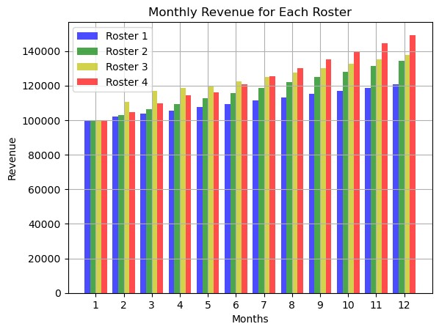

Please note that the churn rate, number of customers, and monthly revenue will change each month due to the churn reduction and revenue increase effects from Account Managers and Support Agents. Additionally, the number of new customers acquired by New Business Acquisition personnel will contribute to the growth in customer base and revenue. The churn rate and customer count will adjust each month based on these factors.

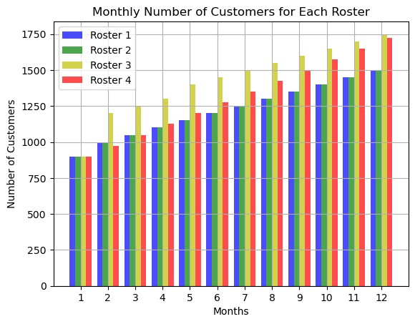

**Final Resource Allocation Decisions:**

The optimal resource allocation decisions were made through iterative simulations and analysis. We calculated the staff allocation and monthly outputs for various scenarios to find the configuration that maximizes SaaSafras' run rate revenue 12 months from now.

**ROSTER 4** combination achieves the highest revenue in month 12. This roster had an even mix of team members with New Business having the highest with 7 and Account Managers and Support agents having 6 respectively.

**ROSTER 3** performed well next to roster 4 with the highest Customer retention rate with 1750 customers at the end of the 12th month but slightly lesser revenue than roster 4.

**ROSTER 1** performed the least having 10 support agents and 5 NBs and AMs respectively hence for optimum revenue and customer retention you need more NBs and AMs than Support Agents.

**ROSTER 2** performed low as well with 10 Account managers and 5 NBs and SAs respectively, this also shows having more Account mangers will not yield optimal revenue in 12 months.

In conclusion, Roster 3 having 10 New Business and yielding the best of all 3 similar simulations than 10 Account Managers and 10 Support agents shows, a simulation with more new business staff will produce the best resource allocation for the 12-month period.

Furthermore, a simulation similar to cross validation in machine learning of more than 6 NBs to 18 NBs will show the best model and how many staff will be required in each team to achieve the most optimal result in revenue and customer retention.

Additionally, real-time data and performance feedback may be considered to fine-tune the resource allocation decisions throughout the 12-month period to adapt to market dynamics and changes in customer behavior.

**Case study files, codes and resources can be found in the link below:**

<https://github.com/MoAbbazi/Maple-SaaSafras-Case-Study-Prompt>

**Case studies done similar to this can be found in the link below:**

<https://github.com/MoAbbazi?tab=repositories>

**Tola Abrahams.**

**+19296025611 / tom4tech8@gmail.com.**